Day 3 – JS Basics

Go over dev tools in the browser and how they work.

Show students how to modify the code via the console.



Go over what comments are, why they are important, the two different types.

Go over arithmetic operators

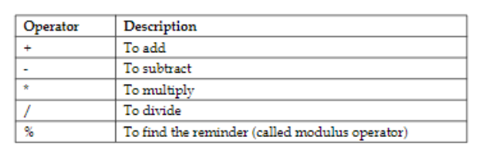

Go over some if not all of the exercises below.

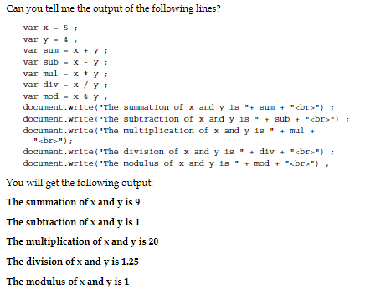

Go over comparison and logical operators.

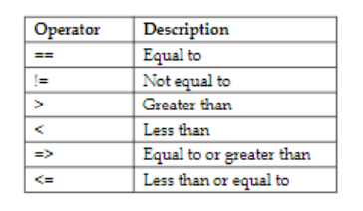

&& || !=

**JS Shell 1 – The Metroficator**

1. Add the script tag into the HTML
2. Add use strict
3. Make sure all variables are properly declared. (const or let)
4. Make sure to output variables with 2 decimal places.
5. Make sure everything works.

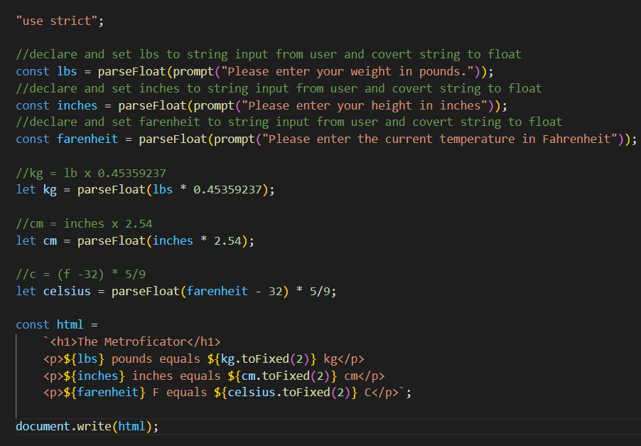

**Break**

**JS Shell 2 – Space Weight**

1. Add the script tag into the HTML
2. Add use strict
3. Make sure all of the variables are declared properly. (const or let)
4. Cargo weight needs to be an array.
5. Inside the do-while loop add an if statement that checks if the item weight is more than or equal to 0. Inside that, add the item weight to the end of the array.
6. Add an else if statement if item weight is not equal to exit. Inside that, add an alert letting the user know they have entered an invalid number.

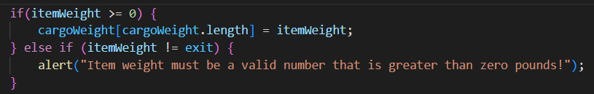

1. Add a for loop under the do while loop to get one item from the array. Inside that for loop, add the items from the array to the total cargo weight.

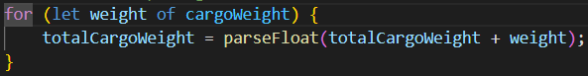

1. Find the average of the cargo weight



1. use template literal to reformat the html variable.

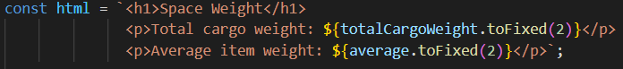

1. Use if statements to determine which text to show

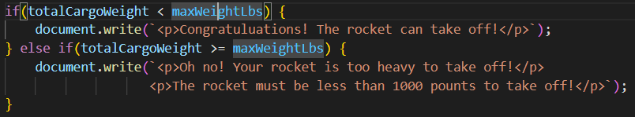

1. Make sure everything works.

**JS Photo Editor Exercise**

**JS Hack A Game Exercise**